MSDS 6371 FALL 2019 Midterm

Question 1

Suppose the following hypotheses are tested:

H0: *μ*=1.4

Ha: *μ*≠1.4

Alpha (*α*) = 0.05

What is the definition of a Type II Error in this context?

Select one:

**A. A Type I Error is failing to reject the null hypothesis if the population mean is 1.5.**

**B. A Type I Error is rejecting the null hypothesis if the population mean is 1.4.**

**C. A Type II Error is failing to reject the null if the population mean is not 1.4.**

**D. A Type II Error is rejecting the null hypothesis if the population mean is not 1.4.**

However, looks like ‘1.5’ got into the answer for A… so I would take that one as well.

Question 2

Suppose a hypothesis test is a performed and p-value of 0.523 is obtained. Which of the following is the correct interpretation of the p-value?

Select one:

**A. There is a 52.3% chance that the null hypothesis is true.**

**B. There is a 52.3% chance that the alternative hypothesis is true.**

**C. There is a 52.3% chance that one would get a test statistic as extreme or more extreme than the observed**

**value by chance alone if the null is true.**

**D. There is a 52.3% chance that one would get a test statistic as extreme or more extreme than the observed**

**value by chance alone if the alternative is true.**

**E. A and C are True**

**F. B and D are True**

**G. None are True**

Question 3

The signed rank test is an alternative to the paired samples t-test. True or False?

Select one:

**A. True**

**B. False**

Question 4

A 95% confidence interval of the difference of means $μ_{1}-μ_{2}$ is found to be [22.3, 25.6]. Which is a correct interpretation of this confidence interval?

Select one:

**A. There is a 95% chance that both $μ_{1}$** and $μ_{2}$ **are each between 22.3 and 25.6.**

**B. There is a 95% chance that both $μ_{1}$** or $μ_{2}$ **is between 22.3 and 25.6.**

**C. We are 95% confident that $μ_{1}$** is larger than $μ_{2}.$

**D**. **We are 95% confident that $μ_{2}$** is larger than $μ_{1}.$

**E. There is a 95% chance that** *x̄1 - x̄2*  **is between 22.3 and 25.6.**

**F. The sample mean***x̄***is likely between 22.3 and 25.6. The procedure used gives a confidence interval containing the sample mean***x̄***for 95% of samples.**

Question 5

All else held constant, which increases the power of a one sample t-test?

Select one (the most appropriate answer):

**A. Increasing the Effect Size only**

**B. Increasing the Sample Size only**

**C. Increasing the significance level only**

**D. A and B will both increase the power of the test.**

**E. A and C will both increase the power of the test.**

**F. B and C will both increase the power of the test.**

**G. All will increase the power of the test.**

**H. None will increase the power of the test.**

Question 6

As long as subjects have been randomly selected from the population, a casual inference can be inferred. True or False.

Select one:

**A. True**

**B. False**

Question 7

Suppose a data set of continuous numbers consists of most of the numbers clustered together with a few outliers much higher than the others (and no other outliers). Choose the best answer that describes the skewness of the data.

Select one:

**A. The data set is skewed to the right.**

**B. The data set is skewed to the left.**

**C. The data set is not skewed. (It is symmetric.)**

**D. There is not enough information to determine skewness.**

Question 8

A researcher for Car and Driver magazine was interested in if there was a difference between the MPGs (miles per gallon) of hybrid cars and their manufacturer. In order to test this, the magazine gained access to 3 Toyota Corolla Hybrid, 4 Ford Fusions and 5 Chevy Malibu Hybrids and recorded the MPGs from each of these cars. From a previous study, there is reason to believe that the distributions of mpgs from these cars are very right skewed and that the standard deviations are similar. What is the best test to test for a difference in the centers between any pair of these distributions?

Select one:

**A. Signed Rank Test**

**B. Rank Sum Test**

**C. Welch's T Test**

**D. Kruskal Wallis Test**

**E. Brown and Forsythe Test**

**F. Pooled T Test**

**G. 1-way ANOVA**

Question 9

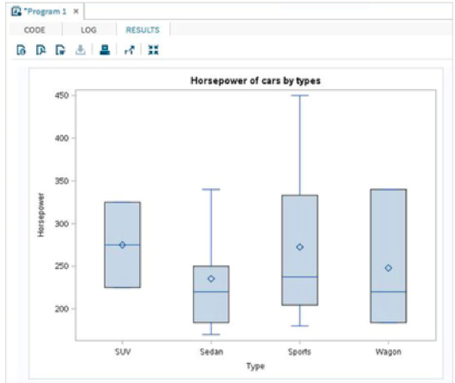

The box plots for the Sedan, Sports and Wagon types above are consistent with:

**A. Left Skewed Data**

**B. Symmetric Data**

**C. Uniformly Distributed Data**

**D. Right Skewed Data**

MSDS 6371 Analysis Question

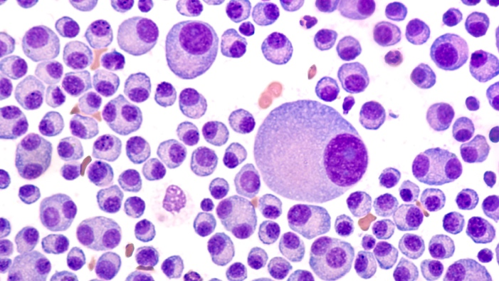

Multiple Myeloma is a relatively rare form of blood cancer in which plasma cells reproduce uncontrollably in the bone marrow. This in turn crowds out read and white blood cells which leads to complications in the patients overall health. The cancer can be monitored by looking at a patient’s *Lambda and Kappa* protein counts. Higher counts indicate more / worse disease. There have been several drugs that have been developed to fight this type of cancer which is measured in the reduction of the *Lamda* and *Kappa* protein levels. Four of these drugs are: Revlimid, Velcade, Dex and Pomolyst.

Through prior studies, all of the drugs have been shown to decrease the Lamda and Kappa proteins in myeloma patients. This study is focused on comparing the four treatments to see which ones are more effective in reducing the Lamda and Kappa protein levels.

To test this, the researchers went to MD Anderson hospital in Houston and randomly selected 35 patient’s records that had been taking one of the drugs above. To be clear, there were 140 patient’s records in the study, 35 patients that took Revlimid, 35 that took Velcade, 35 that took Dex, and 35 that took Pomolyst. The researcher recorded the percentage drop in Lamda protein during the standard 15 month treatment of taking the drug. This data is recorded in the file myeloma.csv.

Histograms and Box Plots of the percent drops of **Lambda** protein levels are provided below.

|  |  |
| --- | --- |
|  |  |
|  |  |

|  |
| --- |
|  |

***Make sure and provide your SAS or R code for all questions below.***

1. The principal question of interest for the researchers was if there were significant differences in the mean or median percent drop of Lambda protein between the drugs and if there are, and estimate of the magnitude of the difference(s). Provide analysis that will best answer the principle question of interest above. Please address all assumptions needed to conduct your analysis and provide a scope of inference with your findings. Assume the researchers are interested in maintaining a family wise error rate of 5% (alpha_family = .05).

**Problem: Are there significant differences in the mean or median percent drop of Lambda protein between the drugs and if there are, estimate the magnitude of the difference(s).**

**Assumptions:**

**Normality: There is some evidence of the data coming from non-normal distributions although if they do not, it doesn’t look like there is evidence of an extreme departure. With a sample size of 35 in each group the ANOVA and Tukey-Kramer tests should be robust to the normality assumption due to the central limit theorem.**

**Homogeneity (Equal Standard Deviation / Variance): The boxplots of the data above are consistent with the 4 distributions having the same variance / equal standard deviations.**

**Independence: We will assume that these patients are independent of one another, both between and within drug groups.**

**Analysis:**

**ANOVA**

**Since the assumptions of a pooled ANOVA appear to be met, we will first use an ANOVA to test if there is evidence of at least one pair of drug groups that have significantly different means.**

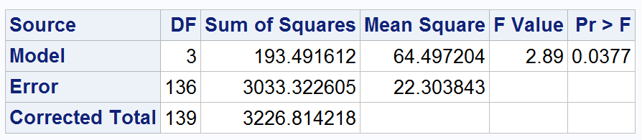

**Step 1:**

**Ho: All mean Lamda protein percent drops are the same among the drug groups.**

**Ha: There is at least 1 pair of drug groups that have different mean percent Lambda protein drop.**

**Step 2: Not necessary that students have this for the ANOVA but have provided it anyway.**

**C.V.: Fcrit = 2.67**

**Step 3: Fstat = 2.89**

**Step 4: pvalue = .0377**

**Step 5: Reject Ho**

**Step 6: There is sufficient evidence to suggest that there is at least 1 pair of drug groups that have different mean percent Lambda protein drop. (pvalue = .0377)**

**For the purpose of this test, the above ANOVA is not required but is preferred. Since the standard deviation and independence assumption are assumed to be met, and the Tukey-Kramer test is assumed to be robust to the normality assumption since all group sample sizes are 35, we will conduct the Tukey Kramer test to test for differences in mean Lambda percent drop between the groups.**

|  |  |
| --- | --- |
| **proc** **glm** data = myeloma;  class drug;  model LambdaDrop = Drug;  means drug / tukey cldiff;  **run**; |  |

|  |  |
| --- | --- |
| **proc** **glm** data = myeloma;  class drug;  model LambdaDrop = Drug;  lsmeans drug / cl adjust = tukey;  **run**; |  |

**As per the Tukey Kramer confidence intervals displayed above, we can see that the evidence suggests that the only significant difference in mean Lambda protein percent drop was between Revlimid and Pomolyst. It is estimated that Revlimid has a greater estimated mean Lambda percent drop and that we are 95% confident (alpha_family = .05) that this difference is contained in the interval (.316%, 6.189%) and that our best estimate would be 3.25%.**

**Scope: This study was a random sample of patient records from M.D. Anderson and thus the results above can be generalized to the population of all M.D. Anderson myeloma patients from this time period. In addition, since this study was conducted from patients that came into the study with their drug assignments, this was an observational study rather than a randomized experiment. For this reason, only an association can be drawn between the drop in percent lost and the given drug. No causal inference can be drawn from this study.**

1. A second question of interest centered on comparing Type A drugs to Type B drugs. Turns out that Revlimid and Velcade are Type A drugs while Dex and Pomolyst are both Type B drugs. Test the claim that the Type A drugs have a greater mean percent drop of Lambda protein than the Type B drugs by comparing the mean percent drop of Revlimid and Velcade to the mean percent drop of Dex and Pomolyst using a contrast. For this question you may assume all the assumptions are met to run a contrast but do show all 6 steps of the hypothesis test (t test) and provide a 95% confidence interval for the difference as well. Test at the alpha = .01 level of significance.

**Problem: Test the claim that the Type A drugs have a greater mean percent drop of Lambda protein than the Type B drugs by comparing the mean percent drop of Revlimid and Velcade to the mean percent drop of Dex and Pomolyst using a contrast.**

**Assumptions: Assumed to be met … given in the problem.**

**CONTRAST (T-TEST)**

**Step 1:**

$$Ho: \frac{μ_{R}+μ_{V}}{2}=\frac{μ_{D}+μ_{P}}{2}$$

$$Ha: \frac{μ_{R}+μ_{V}}{2}≠\frac{μ_{D}+μ_{P}}{2}$$

**Step 2:**

**This was a t test thus we it is expected to provide a critical value.**

**tcrit = t.995,136 = +/- 2.61 (df = 136)**

**Step 3:**

**tstat = 2.18**

**Step 4: pvalue = .0312**

**Step 5: FTR Ho**

**Step 6: There is not enough evidence to suggest that the average of the mean percent drop of Revlimid and Velcade (Type A) is different than the average mean percent drop of Dex and Pomolyst (Type B) (pvalue = .0312). A 99% confidence interval for the difference between the Type A and Type B mean Lambda protein percent drop is (1.74 – 2.61*.798, 1.74 + 2.61*.798) = (-0.34728%, 3.82278%).**

|  |
| --- |
| **proc** **glm** data = myeloma;  class drug;  model LambdaDrop = Drug;  lsmeans drug / cl adjust = tukey;  estimate "Average percent lost of Typa A versus Average percent lost of Type B" drug -**1** -**1** **1** **1**;  **run**; |
|  |

1. BONUS (5 pts) **KAPPA** PROTEIN ANALYSIS: The researchers thought that Revlimid would be more effective than the Velcade in reducing the **Kappa** protein levels. One problem they encountered was that the Kappa percent reduction was missing for many of the Revlimid and Velcade patients (as can be seen in the data set). Conduct a complete analysis (state the problem, address the assumptions, conduct the 6 step test and provide a scope of inference) that will test the claim that the Revlimid has a greater mean or median percent drop in **Kappa** protein levels than Velcade. Use an alpha = .01 level of significance and provide confidence intervals with your analysis.

|  |  |
| --- | --- |
|  |  |
|  |  |

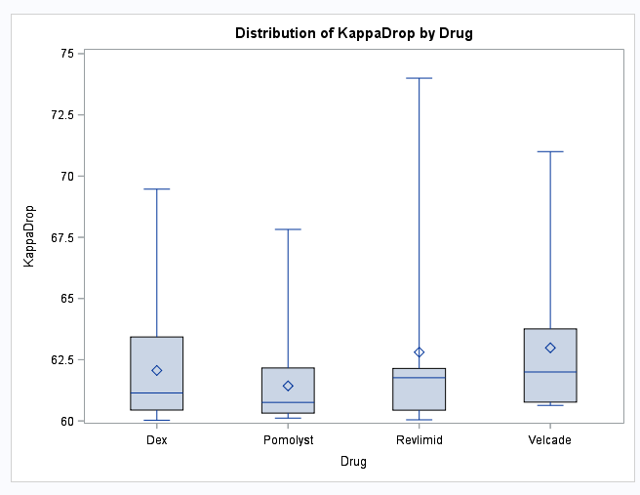

**Problem: Test the claim that Revlimid would be more effective than the Velcade in reducing the Kappa protein levels.**

**Assumptions:**

**Normality: Judging from the histograms, there is strong evidence against normality given the prominent right skew in the data.**

**Equal Standard Deviations: Judging from the box plot there is some but arguably minimal given the sample size, evidence against equal standard deviations.**

**Independence: Again we will assume that observations are independent both within and between the drug groups.**

**Since normality is questionable and we have very small sample sizes, we will be conservative and proceed with a Rank Sum test to test for differences in median Kappa protein drop between Revlimid and Velcade.**

|  |  |
| --- | --- |
| **proc npar1way data = myeloma Wilcoxon;**  **where drug eq "Revlimid" | drug eq "Velcade";**  **class drug;**  **var KappaDrop;**  **exact HL;**  **run;** |  |

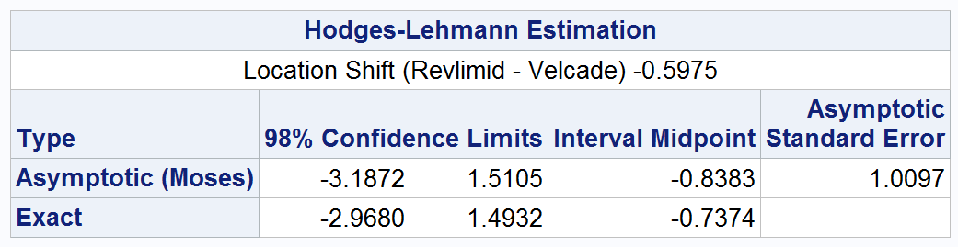

**Step 1:**

**Ho: MedianR = MedianV**

**Ha MedianR > MedianV**

**Step 2:**

**CV: tcrit = 2.55 (df = 20-2 = 18)**

**Step 3: tstat = -.7937**

**Step 4: pvalue = .2186**

**Step 5: FTR Ho**

**Step 6: There is not enough evidence to suggest that the median percent drop in the Kappa protein level from Revlimid is different from that of Velcade (pvalue from Rank Sum test t approximation of .2186). A 98% confidence interval for the difference in medians is (-3.18%, 1.51%) from the Hodges-Lehman estimation method.**

**As mentioned above, this was a random sample from cancer patients at MD Anderson thus we can generalize the above conclusion to all myeloma patients from MD Anderson at that time. Although this was an observational study, the distinction between causation and association is a moot point here since no significance was found.**